in partnership with


ICT40515 Certificate IV in Programming
  - Adding a back-end to hold data sent by your applications
SP3/Module 5 Assessment

Assessment: 33127/02

© Open Colleges Pty Ltd, 2016

All rights reserved. No part of the material protected by this copyright may be reproduced or utilised in any form or by any means, electronic or mechanical, including photocopying, recording, or by any information storage and retrieval system, without permission in writing from the copyright owner.

All terms mentioned in this text that are known to be trademarks or service marks have been appropriately capitalised. Use of a term in this text should not be regarded as affecting the validity of any trademark or service mark.

Assessment task 33127/02

Introduction
This assessment will test your skills and knowledge gained through completing the learning and activities in Module 5: Adding a back-end to hold data sent by your applications.
This is a three-part assessment – this first assessment part (33127/01) will need to be completed and submitted to your trainer for marking and feedback before you move onto the second part (PART B: 33127/02). The third assessment is a short answer questionnaire (33127/03).
In the first two assessments (Part A and Part B), you will be presented with a case study which describes a business owner who requires your help to design and create a database to replace her Excel spreadsheet used for the recording of sales.
In Part A, you will analyse the current system and create a database design to streamline her business needs. You will present a report on your analysis and the database design.
In Part B you will create the database and tables, a database diagram, a number of SQL queries, views, stored procedures and functions for use by developers who will eventually create a front end application to the database you create.
In Part C you will provide short answers to a number of questions which will test your knowledge on databases.
Please use the checklist at the end of this document to ensure you have provided all the necessary pieces of evidence for this assessment.

Note – you must successfully complete ALL assessments (33127/01, 33127/02 and 33127/03) to achieve competency in:

ICTDBS403 Create basic databases
ICTPRG402 Apply query language
ICTSAD501 Model data objects

CASE STUDY

Carlotta’s Antique Jewellery
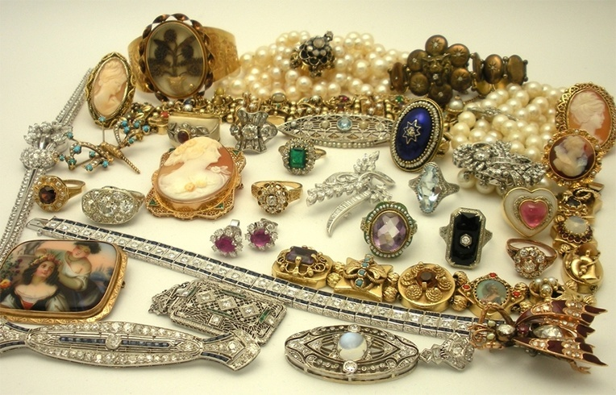
Image:bookstube

Outline

Carlotta sells antique jewellery from a shop in Sydney. She sources her jewellery from deceased estates and resellers. Carlotta is particular of the type of antique jewellery she stocks, only purchasing high end and unique jewellery. She usually prefers to purchase jewellery made before 1940, but will consider purchasing jewellery crafted between 1940 and 1960 depending on the quality of the item. Her customers all have an appreciation for rare and old jewellery.

Carlotta currently records sales on a spreadsheet. She has a separate spreadsheet for each year. You can download a sample of her spreadsheet here.

She records the customer’s name and address, the items(s) they have purchased, the type of jewellery and year it was made, the date of sale and the sale amount of the item in addition to the total sale amount. Each piece of jewellery sold is unique, that is no pieces of jewellery are the same. She also records the age group that her customers belong to so that she can do some marketing analysis. She caters for up to three sale items. If a customer purchases more than three items, she creates another line. Finally, she also records if they want to receive her newsletter.

After a few years, her system of recording sales has become unmanageable. Sales analysis has become extremely difficult as information is dispersed across multiple spreadsheets. She has heard that a database will solve her problems and make sales recording much easier. She requires the following information from the database: a mailing list for customers who want to receive her newsletter, a list of sales by item type, a list of sales by customer category and sales by month.
She has come to you to design and develop a database for her. Your findings and analysis will be compiled into a report.

PART B: Tasks 1–5
CREATE AND QUERY THE DATABASE

Thoroughly read the case study above and highlight, make notes, or extract the important information about Carlotta’s Antique Jewellery. In the following tasks you will need to use this information to investigate the project further.

Task 1: Create the database and tables.
Task 1.1
In Microsoft SQL Server Management Studio (MS), create a database called ‘Antiques’. Create a role for this database called ‘Admin’. Create a login called ‘Carlotta’ with a password of ‘sqlexpress’ mapped to this database. Map this login to the role ‘Admin’.
Task 1.2
From your database schema, create the tables (according to specified naming conventions). In each table create:
- relevant columns with appropriate data types
- specify the primary key and associated foreign keys
- add a description for each column in the Column Properties
- set Insert, Delete, Select and Update permissions for the role Admin for the table.
Task 1.3
In MS, create a database diagram with appropriate relationships. When you have created the database diagram, add the diagram to the Database Diagram section of the Database Design Document. To do this, in MS, right click on the database diagram and select Copy Diagram to Clipboard. Go to the Database Design Document, right click on the Database Diagram heading and select Paste.
Task 1.4
Using the SQL Statement INSERT, write INSERT statements to populate tables from spreadsheet data. Save the INSERT statements into a script file called Insert.sql. Populate lookup tables first. For example, the data in the ‘Category’ column from the spreadsheet will populate the ‘Categories’ table. Be sure to insert them in order. Extract the rest of the spreadsheet data into the relevant tables.

Write a SELECT statement for each table to test that data has been inserted. Save the SELECT statements into a script file called Select.sql. Ensure the rows inserted match the rows returned.
Task 1.5
Script out the entire database into a script file called AntiquesDatabaseScript.sql. In the Set Scripting Options page, script permissions by clicking on the Advanced button to display the Advanced Scripting Options screen. Scroll down to Script Object-Level Permissions and change to True, then click on the OK button and continue with scripting the database.
Task 1.6
Create the data dictionary and save to a file called AntiquesDataDictionary.csv. Refer to the activity Displaying the data dictionary in topic 5.3.4 on creating the data dictionary.

Refer to the activity Scripting the entire database in topic 5.4.4 on how to script out the entire database.
Submit:
- A database diagram in the Database Design Document (replace the rough database schema).
- The INSERT script.
- The SELECT script.
- The database script.
- The data dictionary

Task 2: Develop Queries
You have created the database and populated it with data. Now you need to create SQL queries that can provide Carlotta with the information she requires to help market her jewellery.

Write the following SQL queries and save all of the queries in a single script file. Save the script file as Queries.sql. As you complete each query, comment out the SQL code and write the next query underneath. Ensure that each column is preceded by the table name, for example: Customers.FirstName
Task 2.1
Write a query that lists the customer’s name and address details.
Task 2.2
Write a query that lists the customer’s name, address details and the category they belong to.
Task 2.3
Write a query that lists the item’s description, year made, price and item type. List in ascending order on the ‘description’ column, then in descending order on the ‘year made’ column.
Task 2.4
Write a query that lists the customer’s name and address details for customers who want to receive the newsletter.
Task 2.5
Write a query that lists the item’s description, year made, price and the item type where the year made is before and including 1940 and the item type is either of the women’s item types. List in ascending order on the description column, then in descending order on the year made column.
Task 2.6
Write a query that lists the customer’s name, address details and the category they belong to for customers who are under the age of 50 and have a last name contiaining the letter S.
Task 2.7
Write a query that lists the customer’s name, sale date, item sold and the price for sales made between 03 Jun 2016 and 06 Jun 2016. Order by sale date.
Task 2.8
Write a query that lists the minimum, maximum and average sale price for all items. Use appropriate alias.
Task 2.9
Write a query that lists the sale number, sale date, customer’s name and the total sale price. Order by sale number.
Task 2.10
Write a query that displays the number of sales made between 03 Jun 2016 and 06 Jun 2016.
Task 2.11
Write a query that displays the first letter of the customer’s first name combined with the customer’s last name with a space in between. Also, display the length of the combined first and last name of the customer with a space between the first and last name.
Task 2.12
Write a query that displays the number of days between the earliest sale date and the latest sale date.

Submit:
- SQL statements for the above 12 queries in the Queries.sql file.

Task 3: Develop Stored Procedures
Create the following six stored procedures for the Customers table:
- A stored procedure to insert customer details.
- A stored procedure to update customer details.
- A stored procedure to check if a customer row can be deleted.
- A stored procedure to delete a customer.
- A stored procedure to check if a customer already exists in the database.
- A stored procedure that lists either a specific customer or all customers.
Use appropriate naming conventions for the stored procedures.
Once you have created these six stored procedures, script them into a file titled CustomerSTP.sql.
Submit:
- SQL statements for the above six stored procedures in the CustomerSTP.sql file.

Task 4: Develop a View and a Function
Task 4.1
Create a Function that calculates the Goods and Services tax (GST) on an item’s price. GST is 10% of the sale price. Pass the sale price to the function and return the GST amount. Use appropriate naming conventions for the view.
Task 4.2
Create a View that lists all sale details. Columns to be listed are sale number, sale date, first name, last name, category, item description, item type, year made, price, GST amount (use the function you created in the previous task) and the total sale price (original price plus GST). Use appropriate naming conventions for the view.
Once you have created the function and view, script these function and view into a file titled Sales.sql.

Submit:
- SQL statements for the above function and view in the Sales.sql file.

Task 5
Submit report for approval.
Your assessor will act as the client for Carlotta. The Database Design Document is to be re-submitted to the client for final approval.

Next steps for you:
You have now reached the end of this assessment.
Ensure that you have completed all of the above tasks. Use the checklist on the next page to double check that you have provided everything required for this assessment submission.
Zip your eight files (Database Design Document, Insert.sql, Select.sql, Data Dictionary, AntiquesDatabaseScript.sql, Queries.sql, CustomerSTP.sql and Sales.sql) and upload to OpenSpace. Label your file your StudentNumber_33127_02. E.g. 665437_33127_02.zip
Your trainer will provide you with feedback for this PART B assessment – ensure that you read this feedback carefully as the trainer will be acting as ‘the client’.
Checklist of items to submit as evidence for this assessment:

PART B
TASK 1 | Database Diagram: Database Design Document
TASK 1 | INSERT script
TASK 1 | SELECT script
TASK 1 | Data dictionary
TASK 1 | Database script
TASK 2 | Scripted SQL statements for the 12 queries in a file titled Queries.sql.
TASK 3 | Scripted SQL statements for the six stored procedures in a file titled CustomerSTP.sql.
TASK 4 | Scripted SQL statements for the function and view in a file titled Sales.sql
Name each assessment file appropriately and submit for marking.

